A case of conjoining heart with a single anterior circulatory system and duplicated posterior circulatory systems in Poecilotheria metallica (Pocock, 1899)

Hayward Wong

Abstract
Research on conjoining in arachnids is limited, with few documented cases and scant exploration of circulatory systems and heart anatomy. This study examines a unique female Poecilotheria metallica exhibiting a double folium pattern on the opisthosoma, hypothesising that this may indicate conjoined hearts. Following the unexpected death of the specimen, dissection revealed a conjoined heart with dual cardiac structures, confirming partial validity of the initial hypothesis. The circulatory system displayed a standard anterior aorta but an unusual duplication in the posterior circulatory system, with two posterior aortas branching from a split heart. This arrangement correlates with the external split folio pattern, suggesting a morphological relationship between the circulatory anomaly and external markings. This investigation provides valuable insights into the anatomy of conjoined arachnid specimens, laying the groundwork for future research into the physiological implications of such anomalies in arachnids.

Introduction
Research on conjoining in arachnids is generally scarce, with few documented cases or comprehensive studies available. Similarly, the circulatory systems and anatomy of arachnid hearts are seldom explored in detail, with most existing literature addressing only fundamental structural and functional characteristics. Previous research has shown that simple fusions in the opisthosoma (abdomen) pattern can often be recognised by an asymmetrical folium (leaf-like pattern), where only a few cells within the opisthosoma markings are duplicated (Gabriel 2010, 2011a) (see Fig. 1,2,3,4,5). In cases of more pronounced fusion, the folium can be partially or entirely doubled, as evidenced by the presence of half a folium on one side of the opisthosoma (Gabriel 2011) (see Fig. 6). Upon further research, I noticed while anatomical anomalies such as ocular (eyes) and limbs conjoining were documented (Gabriel & Sherwood 2020), most previous accounts of opisthosoma fusion anomalies focused on the appearance of its pattern and in case of females, the conjoining of spermatheca (Gabriel 2011b, 2011c, Sherwood et al. 2021, see Fig. 7,8), but other anatomical differences were not well documented. While not all folio patterns are identical and fully symmetrical, double folium is certainly rare. Most specimens that exhibit obvious conjoining traits, such as two sets of spinnerets (see Fig. 9) or two abdomens, also display some form of split folium. I believe that this type of fusion may extend beyond merely the opisthosoma pattern and could have further physiological implications.

In 2022 I acquired a female Poecilotheria metallica specimen with an abnormal opisthosoma pattern with two distinct and complete folium (see Fig. 10). I hypothesised that the split folium might be a result of conjoining and the specimen in question might have two hearts. This idea stemmed from a previous experience with a Pamphobeteus ultramarinus matured male. Upon handling the deceased tarantula, the abdominal skin ruptured, and the entire abdomen slid out in one piece, revealing a fully intact heart extending dorso-medially along the anterior part of the opisthosoma (see Fig. 11). This observation made me realise that the folio pattern found in Poecilotheria resembles the shape of the tubular heart and its cardiac arteries. Thus, a double folium could indicate the presence of two hearts.

Although I initially planned to bring this specimen to the BTS spider competition when it matures, breeding and letting it live its fullest life before conducting any dissection, it died unexpectedly at the sub-adult stage. Unfortunately, I did not notice the death immediately, and by the time I discovered the specimen, it had begun to emit a foul odour. Lacking experience with proper tarantula preservation techniques, I opted to freeze the specimen after the opisthosoma was examined, which ultimately limited the scope of this investigation. Further discussions with Ray Gabriel, inspired me to still document and publish this case of conjoining. To my knowledge, the study of conjoined hearts in arachnids remains entirely unexplored, and no previous dissections of such specimens have been conducted, making this case a novel contribution to the study of anatomical anomalies in arachnids, despite the damage to the specimen.

Materials and Methods
Poecilotheria metallica like other species from the same genus has a distinctive, bilaterally symmetrical folium on the dorsal side of the opisthosoma, running from the anterior (front) to the posterior (back) end. This female Poecilotheria metallica however possesses two complete folium (see Fig. 10). This specimen underwent multiple moults under my care, consistently retaining this double folium. Despite this, there were no observable signs of conjoining in other body parts—the spermatheca remained singular (see Fig. 12), and only one set of spinnerets was present. The abdomen was symmetrically shaped with no bulges or other physical anomalies, aside from the folio pattern.

I created an incision on the side of the opisthosoma using a scalpel, carefully peeling back the exoskeleton to reveal a solid mass of tissue. Notably, visible mould was forming on the surface of the skinned opisthosoma, and I was fortunate to have performed the dissection before further deterioration could compromise the integrity of the specimen.

Results
As soon as I removed the exoskeleton, I discovered a heart with an unusual morphology, unlike anything I had encountered previously (see Fig. 13). Although this specimen does not have two separate hearts, it indeed possessed a conjoined heart, splitting at the posterior end to resemble the shape of its folio pattern (see Fig. 13A), partially confirming my initial suspicions. The dissection was primarily concentrated on the opisthosoma (abdomen), revealing intricate details of the circulatory system, while the prosoma (cephalothorax) was not thoroughly examined. No signs of conjoining were observed in the prosoma, which aligns with previous research on spider circulation. According to Paul et al. (1989), spiders exhibit a functional separation between anterior and posterior circulatory systems, with haemolymph from the prosoma passing exclusively through the anterior book lungs, and haemolymph from the opisthosoma passing through the posterior lungs. In this specimen, however, the duplication of the posterior circulatory system (see Fig.13B) indicated an unusual conjoining event, presenting an opportunity to examine this rare anomaly.

In the anterior portion, the tubular heart (th, see Fig. 14) was conjoined, giving rise to a single anterior aorta (aa, see Fig. 14) that emanated from the anterior end of the heart. This aorta extended through the pedicel (pe, see Fig. 14) to supply the prosoma, indicating that the anterior circulatory system followed typical spider physiology with no apparent duplication or divergence.

In the posterior section, a more complex arrangement was identified. A normal tubular heart narrows and passes into the posterior aorta (pa, see Fig. 14), with paired cardiac arteries (ca, see Fig. 14) branched ventro-laterally from both sides of the heart, exhibiting significant branching and vascularisation, suggesting an enhanced circulatory network to supply the entirety of the opisthosoma. However, in this specimen, the tubular heart split into two distinct posterior ends, each connected to its own separated posterior aorta.

The cardiac arteries from the separated ends of the heart converged dorso-medially (cca, see Fig. 14), forming a unified vascular structure in the middle of the opisthosoma. However, the cardiac arteries on the sides remained separate, supplying each side of the opisthosoma independently. This unique fused circulatory configuration was seemingly reflected externally by the split folio pattern observed on the dorsal surface of the tarantula.

Discussion
This dissection illustrates the correlation between the duplication of the posterior circulatory system and the external folio pattern. The presence of two posterior aortas and the fusion of certain cardiac arteries parallels the split folium, suggesting a morphological and physiological relationship between the vascular anomaly and the external markings. This study contributes to understanding the internal architecture of conjoined tarantula specimens and provides a basis for further exploration into the physiological implications of such circulatory anomalies.

Research on conjoining arachnids and arachnids’ circulatory systems are generally limited, making this dissection a preliminary exploration of the anatomical structures in a conjoined specimen. While this investigation provides insight into the morphology of the heart, the underlying causes and functionality of such conjoining are beyond the scope of this study. This work serves as a foundation for future research that may delve deeper into the physiological implications and potential mechanisms driving these unique anatomical features in arachnids.

This dissection illustrates the correlation between the duplication of the posterior circulatory system and the external folio pattern. The presence of two posterior aortas and the fusion of certain cardiac arteries parallels the split folium, suggesting a morphological and physiological relationship between the vascular anomaly and the external markings. This study contributes to understanding the internal architecture of conjoined tarantula specimens and provides a basis for further exploration into the physiological implications of such circulatory anomalies.

Research on conjoining arachnids and arachnids’ circulatory systems is generally limited, making this dissection a preliminary exploration of the anatomical structures in a conjoined specimen. While this investigation provides insight into the morphology of the heart, the underlying causes and functionality of such conjoining are beyond the scope of this study. However, it is worth considering whether this anomaly stems from a genetic mutation affecting segmentation genes, such as those in the HOX or SOX family, which regulate body patterning in arthropods. In insects, defects in these genes have been associated with duplication of limbs and other body structures, raising the possibility that a similar developmental error could have led to the observed circulatory duplication in this tarantula.

Alternatively, this case may represent a true instance of conjoining, analogous to conjoined twinning in vertebrates, rather than a localized developmental defect. If so, this would suggest an incomplete embryonic division, a phenomenon rarely documented in arachnids. Distinguishing between these possibilities would require further investigation, potentially including molecular or histological analysis of preserved tissues to identify any genetic or developmental markers associated with this condition.

This study contributes to the documentation of conjoining anomalies in theraphosid spiders by presenting a novel case of a duplicated posterior circulatory system. Given the rarity of this condition, it is unclear whether it arises from errors in early embryonic development, such as genetic mutation affecting segmentation genes, or represents a true case of conjoined twinning. Given the large number of tarantulas bred in captivity, it is likely that further examples of double folium pattern will emerge with continued observation. Documentation of such specimens will help determine whether the presence of a split folium pattern consistently correlates with a conjoined circulatory system and refine our understanding of developmental anomalies in arachnids and their potential underlying causes.

Acknowledgements
Thanks must be given to Ray Gabriel, and to the pints we shared before the BTS show, without which this paper would never have been written. His insights and our discussions were invaluable in shaping the direction of this study.

Special thanks to Thorsten Krose for generously allowing me to use his photo.

References
Paul, R., Tiling, K., Focke, P., & Linzen, B. (1989). Heart and circulatory functions in a spider (Eurypelma californicum): the effects of hydraulic force generation. Journal of Comparative Physiology B, 158, 673-687.

Gabriel, R. (2010). Siamesische oder zusammengewachsene Zwillinge bei Poecilotheria regalis Pocock, 1899. ARACHNE 15(3): 33-40.

Gabriel, R. (2011a). Weitere Fälle von zusammengewachsenen Vogelspinnen (Araneae: Theraphosidae). ARACHNE, 16(6): 4–7.

Gabriel, R. (2011b). Beispiele von zusammengewachsenen Spermatheken bei Vogelspinnen (Araneae, Mygalomorphae, Theraphosidae). ARACHNE 16(2): 24-27.

Gabriel, R. (2011c). Nhandu carapoensis Lucas 1983 the senior synonym of Nhandu tripartitis Schmidt 1997, (Araneae: Theraphosidae), Newsl. Br. Arachnol. Soc., 121: 11–13.

Gabriel, R., & Sherwood, D. (2020). Further cases of conjoining anomaly in theraphosid spiders (Araneae: Theraphosidae). Acta Arachnologica, 69(1), 27-30.

Sherwood, D., Gabriel, R., Lucas, S. M., & Brescovit, A. D. (2021). An anomalous spermathecae resolved after moulting events in a female of Hapalopus Ausserer, 1875 with a review of spermathecal anomalies in theraphosid spiders (Araneae: Theraphosidae). Revista Ibérica de Aracnología, 39, 139-143.

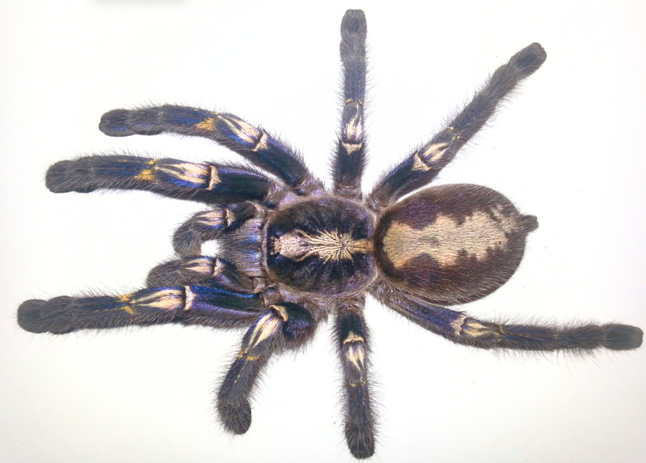
Fig. 1: Asymmetrical folio of a Poecilotheria metallica photo: Hayward Wong
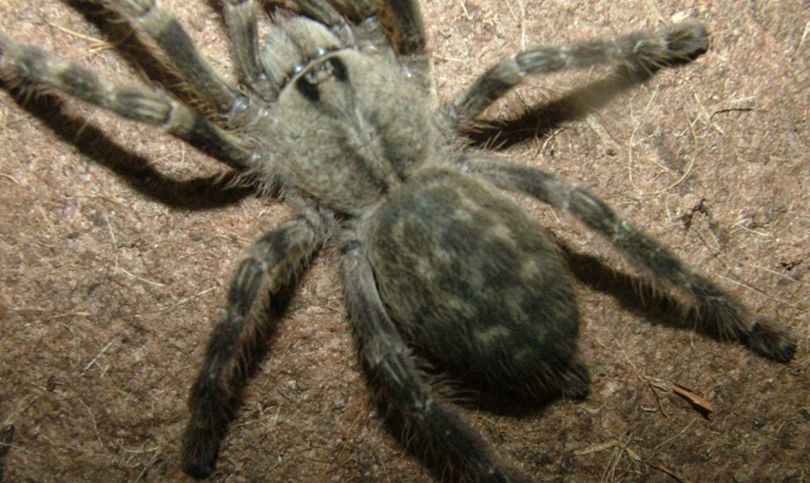
Fig. 2: Asymmetrical folio of a Poecilotheria fasciata photo: Ray Gabriel 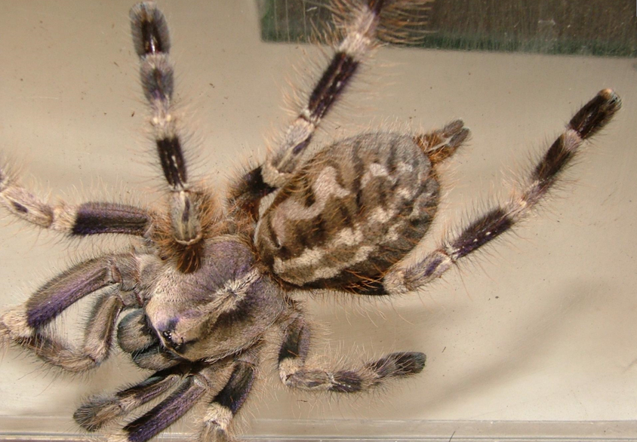
Fig. 3: Asymmetrical folio of a Poecilotheria mirnada photo: Ray Gabriel

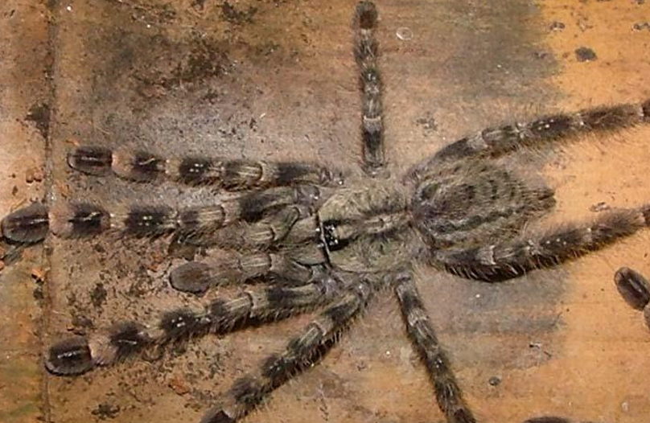
Fig. 4: Asymmetrical folio of a Poecilotheria regalis photo: Ray Gabriel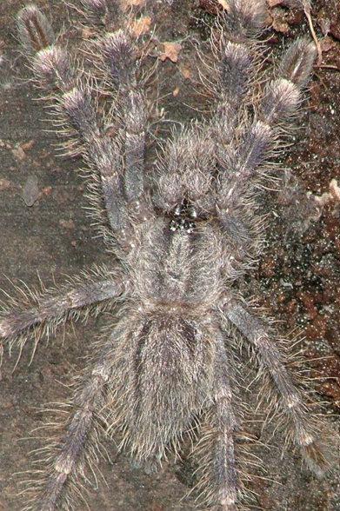
Fig. 5: Asymmetrical folio of a Poecilotheria metallica photo: Ray Gabriel
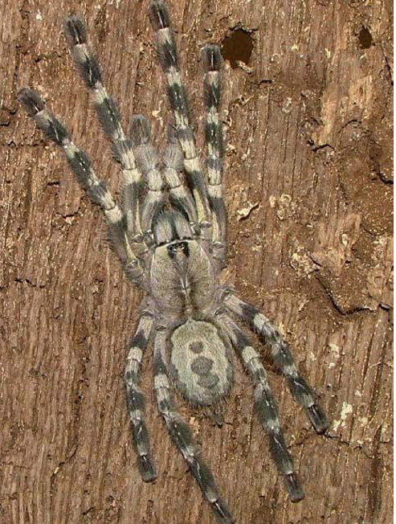
Fig. 6: Poecilotheria regalis with double folium photo: Ray Gabriel
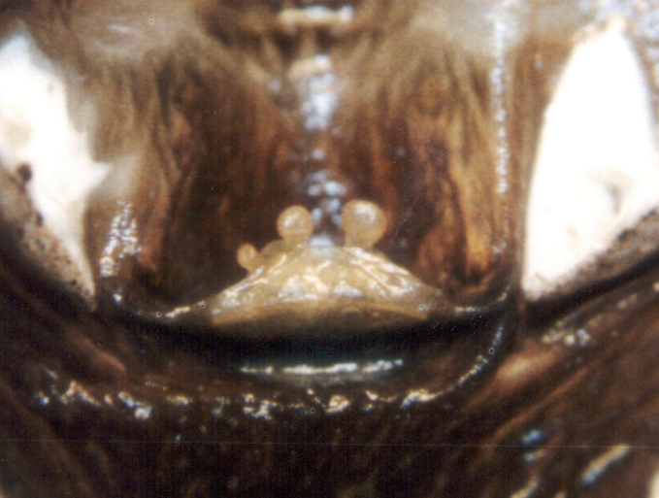
Fig. 7 Acanthoscurria sternalis showing left conjoined spermatheca. Ray Gabriel

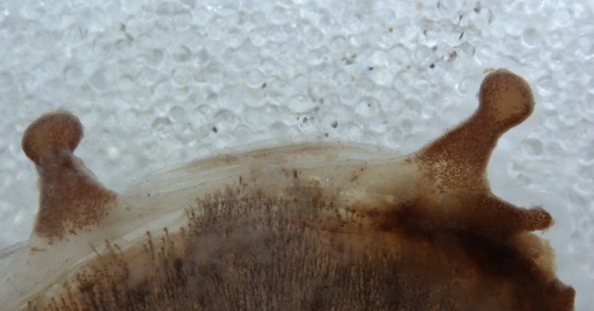
Fig. 8 Grammostola rosea showing right conjoined spermatheca. Ray Gabriel

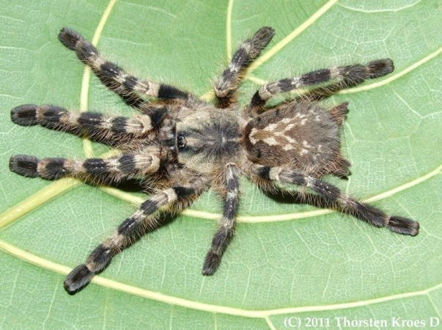
Fig. 9: Poecilotheria tigirnawesseli with double folium and two set of spinnerets photo: Throsten Krose

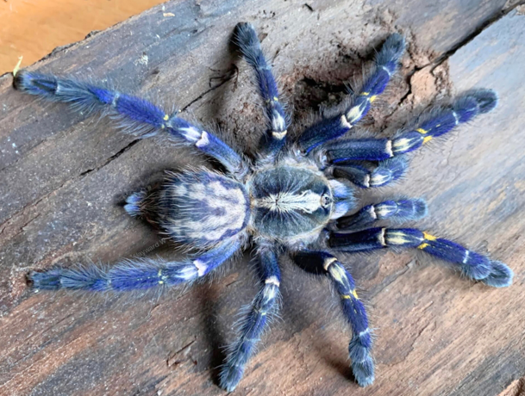
Fig. 10: The conjoined Poecilotheria metallica with double folium photo: Hayward Wong
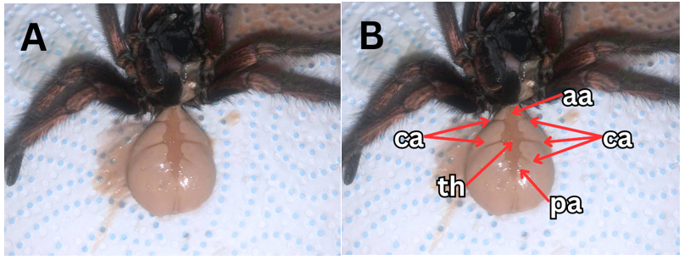
Fig. 11: A) heart of a normal Pamphobeteus ultramarinus matured male, B) Annotated (aa: anterior aorta, th: tubular heart, pa: posterior aorta, ca: cardiac arteries) photo: Hayward Wong

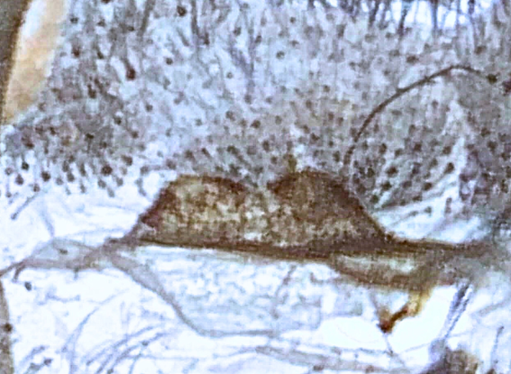
Fig. 12: Spermatheca of the conjoined Poecilotheria metallica photo: Hayward Wong

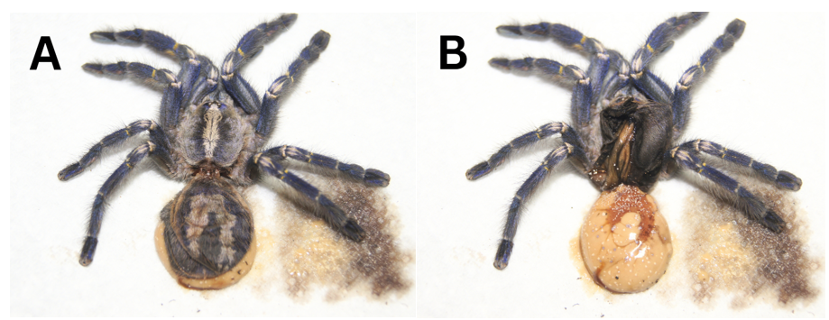
Fig. 13: A) Double folium and B) conjoined heart structure of the conjoined Poecilotheria metallica photo: Hayward Wong

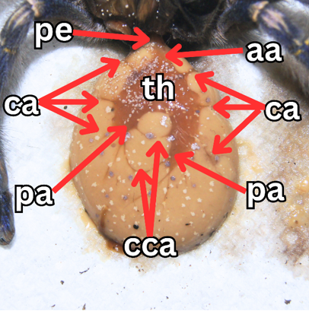
Fig. 14: annotated conjoined heart of the conjoined Poecilotheria metallica (pe: pedicel, aa: anterior aorta, th: tubular heart, pa: posterior aorta, ca: cardiac arteries, cca: converged cardiac arteries) photo: Hayward Wong

